**Positions in early childhood inquiry-based science education: A thematic network analysis review**

**Abstract**

*This review aims to generate condensed knowledge about early childhood inquiry-based science education (ECIBSE). We conducted a systematic search for empirical studies resulting in 35 papers for the review. We then selected theoretical and excerpts from each paper and used a combination of thematic analysis and network analysis to identify structural themes and educational positions within the field of ECIBSE. We analysed theoretical excerpts and then compared themes. We find four positions: (1) that science should be learned/understood through inquiry, (2) that teaching should model scientific practices, (3) that children should develop science-related competencies, and (4) that the child’s exploration and experience should take precedence. We argue that while these four positions are not mutually exclusive, they signal a tension between different intentions and will influence the practical implementations.*

Introduction

Educational policies around the world emphasise inquiry-based science (IBSE) approaches to teaching as vital ingredients in building a scientifically literate community for all age groups and educational levels (Harlen & Allende, 2006), including early childhood levels. Often the work of John Dewey (1859–1952) is highlighted as the origin of inquiry with a focus on fostering curiosity and relating that to scientific practice (Johnson & Christensen, 2014). However, IBSE is conceptualised and implemented in different ways across different contexts and domains, as Rönnebeck et al. (2016) illustrate for the upper secondary level. Even within a single domain and context, IBSE may be conceptualised differently in terms of both theory and implementation of IBSE as is illustrated for middle and secondary school by Martin-Hansen (2002). Such conceptualisations are influenced by original conceptualisations of scientific inquiry (e.g. Dewey) and have impact on what and how children learn through IBSE. For this reason, it is important to unfold both the original roots and modern conceptualisations of IBSE. We argue that this is particularly important for early childhood education (ECE) as early encounters with science learning likely shape children’s future attitudes towards science and science learning (Eshach, H., & Fried, M. N. 2005). Thus, with this review paper, we aim to focus on descriptions of IBSE in ECE literature.

Some ECE conceptualisations mirror approaches found at later educational levels. At these levels, IBSE is often carried out in ways where the learner addresses scientiﬁcally oriented questions in the context of a real-world problem; plan and carry out investigations to gather evidence; give priority to evidence in responding to questions; formulate explanations for evidence; connect explanations to scientiﬁc knowledge; and communicate and justify explanation (Alake-Tuenter et al., 2012; Pedaste et al., 2015). Such an approach to learning science is believed to underpin problem solving skills obtained through children's active participation in experiments (Pedaste et al., 2015). IBSE approaches are often illustrated by inquiry cycles with varying number of phases (Pedaste et al., 2015). For example, Bybee et al. (2006) present the 5E model consisting of: engagement, exploration, explanation, elaboration, and evaluation.

The variety of IBSE conceptualisations has consequences for the validity of analyses that attempt to synthesize the effects of IBSE (Furtak et al., 2012; Rönnebeck et al., 2016). To further add to this unclarity, the investigated age group is not always explicitly mentioned (Leuchter et al., 2014). Different conceptualisations may even be connected or related in different ways. For example, Martin-Hansen (2002) shows how different levels of guidance may fall on a continuum, and the level of guidance may vary over the course of teaching. Also, some conceptualisations may share values with other conceptualisations. However, if these unclarities can be lifted and relationships between conceptualisations be made clear, future syntheses of the effects of IBSE implementations can become potentially more valuable.

The purpose of this study was to provide an analysis of theoretical positions implementations as they are described in the literature concerning IBSE in the age specific context ECE (4-8 years old). The intention was to perform this analysis by systematically reviewing the empirical literature using qualitative and quantitative methods design, which in a interplay mutually strengthen each other to capture both prevalent and more subtle themes.

Our research questions were:

1. Which themes regarding theoretical positions can be identified within early childhood inquiry-based science education (ECIBSE) literature, and how are these themes connected?

The next section provides an overview of the origins of IBSE with a focus on Dewey’s perspective. This overview will serve as an interpretive lens for our later analyses. We then present our methodology, which combines thematic analysis with network analysis to identify theoretical and empirical conceptualisations. The methodology leads to a map of theoretical conceptualisations, , each with unique interconnections and relationships. We describe these maps in detail and discuss the implications for ECIBSE.

The origins of inquiry-based education

IBSE has deep roots in pragmatism, and John Dewey developed pragmatism from the perspective of education (Biesta & William, 2003). He saw thinking as an instrument for action. From this perspective, thinking and knowledge were tools to solve scientific and everyday problems. Dewey advocated “experiential teaching”, in which the learner is viewed as active, instead of passive receptors (Dewey, 2011). Dewey stressed that learning must be rooted as experience and awaken a curiosity about information and new ideas. Learning experiences are viewed as situations where children create and recreate knowledge as part of the educative process. For Dewey, this is the underlying idea of inquiry (Dewey, 1938/2015).

Dewey’s idea of inquiry is related to both contemporary IBSE conceptualisations and the practice of scientific inquiry. For example, for Harlen & Allende (2006), IBSE encompasses experiences that enable children to develop understanding about scientific aspects of the world through the development and use of scientific inquiry skills. For them, a key element of inquiry is the active participation of children in the thinking processes and investigations of scientific phenomena. *Scientific inquiry* refers to the varied ways in which scientists work, the process of investigating how, why, and what, making sense and evidence of data, and interpreting results (Biesta et al. 2003). Dewey (2005) outlines fundamental conceptual phases, such as defining a problem, formulating a hypothesis, and conducting tests, and most inquiry cycles can be seen as elaborations of these phases (Johnson & Christensen, 2014; Biesta et al., 2003).  Importantly, neither scientific inquiry nor IBSE are linear processes - aspects of inquiry interact in complex ways (Alake-Tuenter et al., 2012).

One major difference between scientific inquiry and IBSE is that teachers often know what children may learn, whereas the attained knowledge in scientific inquiry by nature is unknown. Dewey defined inquiry for both children and scientists as “*the controlled or directed transformation of an indeterminate situation into one that is so determinate in its constituent distinctions and relations as to convert the elements of the original situation into a uniﬁed whole”* (Dewey, 2013, p. 108). Combining these perspectives, IBSEmay be said to foster situations in which learners develop coherent scientific understanding through building relations between elements and experiences, which they perceived as unconnected beforehand.

Experiential education relies on the theory of experience, which is central to Dewey’s work. With a ‘philosophy of experience’, he mediates between traditional education and progressive education. Dewey regards both as mis-educative, because neither apply a carefully developed philosophy of experience (Dewey, 1938/2015). For Dewey, experience consists of three mutually dependent categories; situation, interaction, and continuity (Dewey, 1938/2015). ‘Situation’ refers to the fact we interact with other individuals and with objects in a concrete world and our lives here consist of a series of situations. Within a series of situations, continuity needs to emerge before it can contribute to the fulfilment of an educative experience. ‘Interaction’ refers equally to interactions between individuals and objects and interactions between individuals (Dewey, 2005).

Contemporary literature consistently provides evidence that hands-on experience with science phenomena is a necessary (but not sufficient) component for conceptual learning, especially when coupled with guidance from a teacher (Minner et al., 2010). Dewey advocated the facilitation of creative learning environments in which children may undergo development through educative experiences.  In this child-centred approach, adults must pay attention to what children are curious about and interested in to gauge and use the possibilities for children’s development. Activities should not only be based on children’s interest, but attention to children’s interests should guide the adults in choosing instructional strategies and materials to use. For that reason, questions or problems arising from the child’s everyday experiences are meaningful because they are driven by genuine curiosity. From this child-centred perspective then, it is essential to inquiry-based approaches that educative experiences and learning always include values, emotions, the act of doing, and cognition.

Methodology

Thematic analysis/network is a standard tool for qualitatively finding themes and connections in data (Attride-Stirling, 2001; Braun & Clark, 2006). One possible strategy is to conduct a search for relevant and representative literature, analyse and code that literature in order to produce thematic maps. Here, we expand on thematic analysis by integrating network analysis. As shown by AUTHOR et al. (2019), and AUTHOR et al. (in press) this may add to the analysis by highlighting relational aspects of the data.  Here, we first describe how we performed this study’s literature search and then how we performed our thematic network analysis.

Literature search

We performed a literature search to identify studies with relevant ECIBSE focus inspired by Petticrew & Roberts (2008, p. 27) stages for systematic reviews. We started by carefully reading previous reviews of IBSE and ECIBSE. We focused on Alake-Tuenter (2012); Furtak et al. (2012); Minner et al. (2010); Pedaste et al. (2015) and Rönnebeck et al. (2016). These reviews provided information about gaps in the field and relevant keywords, which we used to identify relevant papers. We selected 2 strings i) Population ii) Intervention. We omitted search string iii) Outcome and iv) Comparison because our research questions do not pertain to outcomes or relation between intervention and outcome.

IBSE approaches to teaching are varied both in formats, in terms used and in names given to approaches. We argue that there are several terms for the same overall core ideas.  For example, the United States official bodies have moved away from using the term ‘inquiry’ and now refers to scientific practices instead (National Research Council, 2012). Thus, to not lose important information, in our search, we included inquiry-based education as well as related terms.

*Table 1: Summary of literature search criteria*

|  |  |  |  |
| --- | --- | --- | --- |
| Date range | 01.01.2008-31.01.2019 | Literature language | English |
| Database | EbscoHost (Education): Academic Search Complete, Education Research Complete, ERIC, Psychology and Behavioural Sciences Collection and SocINDEX with Full Text. | | |
| Search string name | Keywords in string | | Syntax |
| POPULATION | Primary school, Kindergarten, Primary education, Child*, Preschool, Early childhood, Preschool class | | "OR” separated items in block |
| INTERVENTION | Inquiry based teaching, Inquiry based science education, Inquiry cycle*, Inquiry-based learning*, Inquiry phases, (IBL), (IBSE), Inquiry learning process*, Inquiry based instruction, Inquiry model, Scientific inquiry, Scientific practices, (IBI), Inquiry based learning framework. | | "OR” separated items in block |
| Search syntax | POPULATION keywords “AND” INTERVENTION keywords | | |

Table 1 summarizes our search criteria, indicating date range, language keywords and database. The POPULATION and INTERVENTION keywords were combined to yield the intersection between ECE and IBSE. We limited ourselves to English-language literature because preliminary searches indicated very few non-English publications. In doing so, we accept the possible exclusion of regions without strong traditions for publishing internationally.

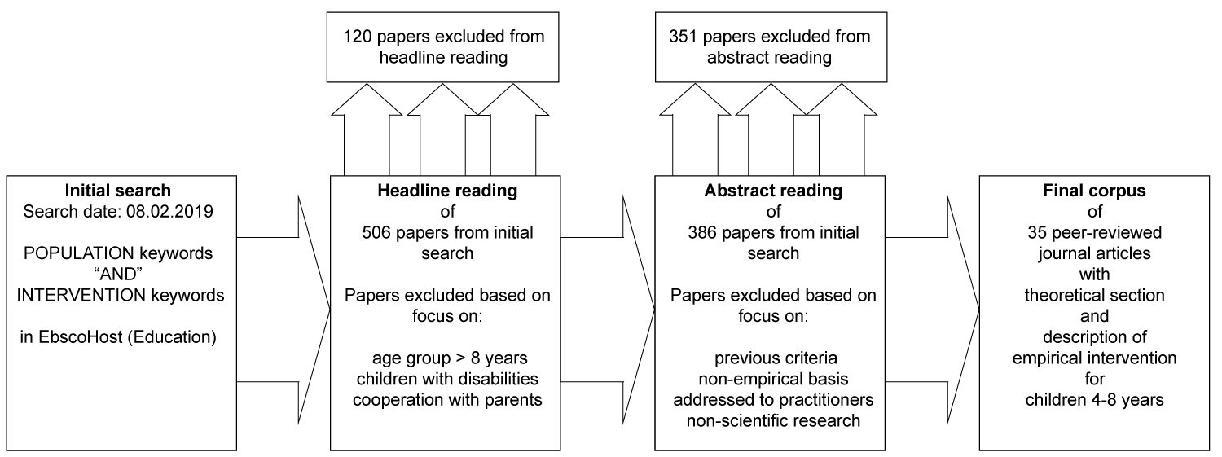

***Figure 1:*** A visualisation of the process leading to the final corpus.

Figure 1 summarizes how we arrived at the final corpus of articles used in this study. We excluded more than a fifth of the initial papers based on reading headlines (Petticrew & Roberts, 2008). A further reading of abstracts resulted in a corpus of 35 peer-reviewed research articles, all of which featured theoretical sections and empirical descriptions of an intervention, where a teacher taught/facilitated learning for 4-8-year-olds.

Selection of excerpts

We made a strategic choice to focus on sections and passages which were clearly part of a theoretical positioning and sections and phrases which were clearly part of an empirical exposition. First author read through each article multiple times and extracted theoretical excerpts and passages. See also the supplemental materials. In the reading process first author systematically were aware of intracoder reliability. Intracoder reliability refers to consistency within a single individual in coding or selecting excerpts (Johnson, 2014).

Thematic network analysis

We analysed the selected excerpts via a modification of thematic discourse network analysis (TDNA). TDNA is an iterative methods approach to analysing and visualising relationships in textual data (AUTHOR et al., 2019; AUTHOR et al. in press). Our modified approach mirrors Braun & Clarke’s (2006) thematic analysis in that we seek to “minimally organise and describe [our] data set in [rich] detail” (p. 79), and want to couple that organisation and description with our reading of the literature to create a convincing narrative about theoretical and empirical descriptions of ECIBSE.

In contrast to Braun & Clarke (2006), we rely on using computer software for creating linguistic networks and maps. Thus, the phases of our approach differ somewhat from Braun (2006). While the description below appears ordered in a linear fashion, our movement from phase to phase was not. For example, we at times went through multiple small loops of generating networks and generating algorithmic rules for changing texts, before generating new thematic maps.

Throughout our analyses, we have used software Gephi 0.9.2 (Bastian, Heymann,& Jacomy, 2009), R (R Core Team, 2019), and RStudio (R StudioTeam, 2020). In R, we have used packages: Igraph (Csardi & Nepusz, 2006) and tm (Feinerer & Hornik, 2019). Our detailed work can be found at GitHub [repository name released upon acceptance of present manuscript; directory attached as supplemental file].

Familiarising with data and generate linguistic networks

In this study, this step was closely connected to the selection of excerpts. The first author built on her reading and selection to identify candidate themes and connections in the data.

As a precursor to generating the linguistic networks, we first implemented any grammatical reductions decided upon (see below). Then, we created weighted and directed linguistic networks where “a directed link is established from *Word A* to *Word B* if *Word B* follows *Word A* in the pre-processed [text]” (Bruun et al. 2019, p. 323). We created two linguistic networks, a ‘theoretical’ and an ‘empirical’. Each network was an amalgamation of excerpts from articles. For example, the combined theoretical network contained all connections in all pre-processed theoretical excerpts from all articles.

Generate algorithmic rules for changing texts

In this critical phase, we decided on grammatical reductions (AUTHOR et al., 2019), such as removing words and deciding on simplified forms.  The rationale for these reductions came from our evolving qualitative analysis. In both early and later stages of the analytical process, we would return to the excerpts before making decisions to see how words were used in the contexts of the different articles.

Generate thematic maps

The purpose of this phase was to reduce the complexity of the network representation of the data while still preserving critical relationships. Inspired by AUTHOR et al. (2019), we used ‘fast-and-greedy community detection’ (Clauset et al., 2004) to find clusters of tightly knit words. These clusters were seen as representations of candidate themes. We then calculated links between clusters/candidate themes by counting the number of word-links between themes. We visualised the map showing only the most prevalent connections (Foti et al., 2011) and, applying community detection again but now on the thematic map, were able to find clusters of themes (represented in colour in Figure 2).

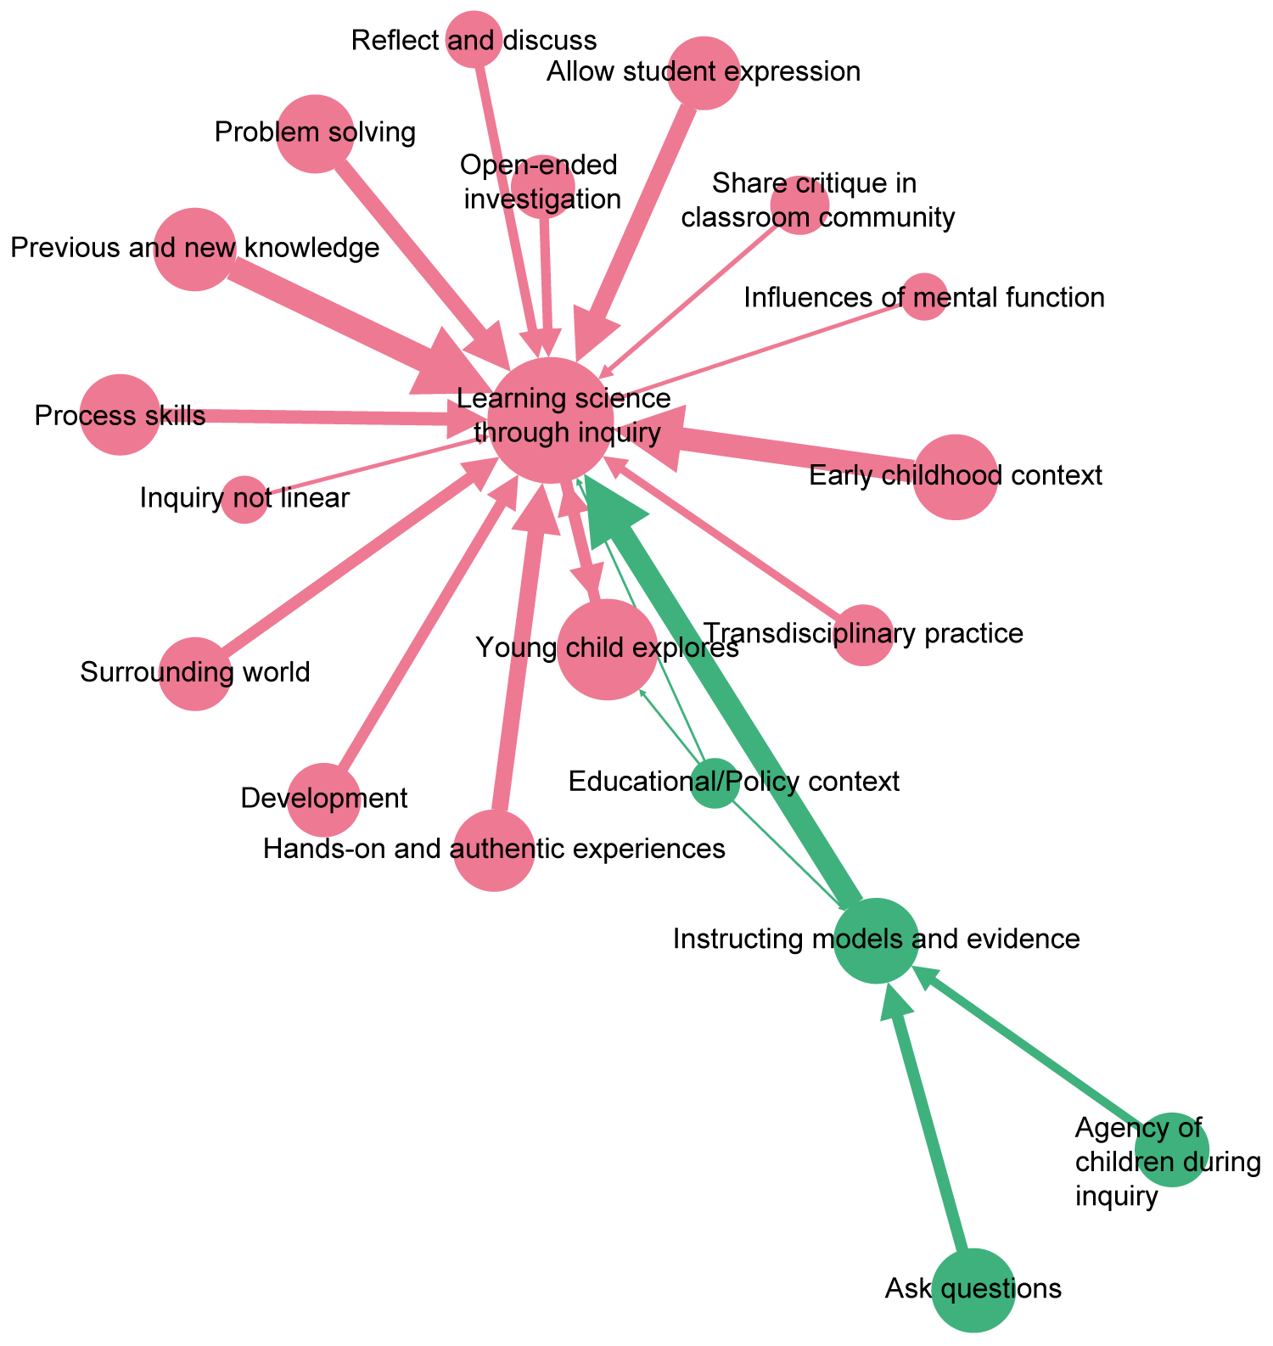

***Figure 2:*** *Thematic map for excerpts. Each circle represents a cluster of words/candidate theme, and each arrow represents word-connections between clusters. Size of circles indicates the number of words contained in that cluster. Circle colours represent clusters of themes found by applying community detection on the map.*

Critical review of themes and thematic maps

This phase involved close comparison between the original excerpt texts and both the thematic maps and the internal structure of themes (each theme is a sub-network of the original network). We scrutinized connections between words and themes, questioned why particular words appeared central or prevalent in the network, and why particular words had been clustered together. This led to new algorithmic rules that were implemented; the results scrutinized again.

Naming and describing themes and between theme patterns

To name a theme, we looked for the most prevalent connections between words and used our evolving understanding as well as less prevalent connections to guide the naming. For example, the theme *Learn science through inquiry* on Figure 2, contained the prevalent connections *science -> learn* and *learn->inquiry,* but also less prevalent ones such as *guide->inquiry* and *understand -> science,* as well as numerous minor connections supported that interpretation. This interpretation corresponded with our reading of the original articles.

Producing report

In reporting our findings, we found that a theme was too prevalent. The theme *Learning science through inquiry* drew attention away from possible underlying hidden patterns relevant for understanding positions. Therefore, in later analyses, we removed this theme from the thematic map and worked with the most prevalent remaining connections between themes. In this paper then, we report on our integrated understanding of the final thematic maps, the network structure of themes, and our careful reading and re-reading of the excerpts.

Themes found with Thematic Network Analysis

Here, we report on our thematic network analysis (TNA) of theoretical excerpts in turn. In each case, we present our final thematic map and then elaborate on themes shown in the map and their connections.

Theoretical Excerpts

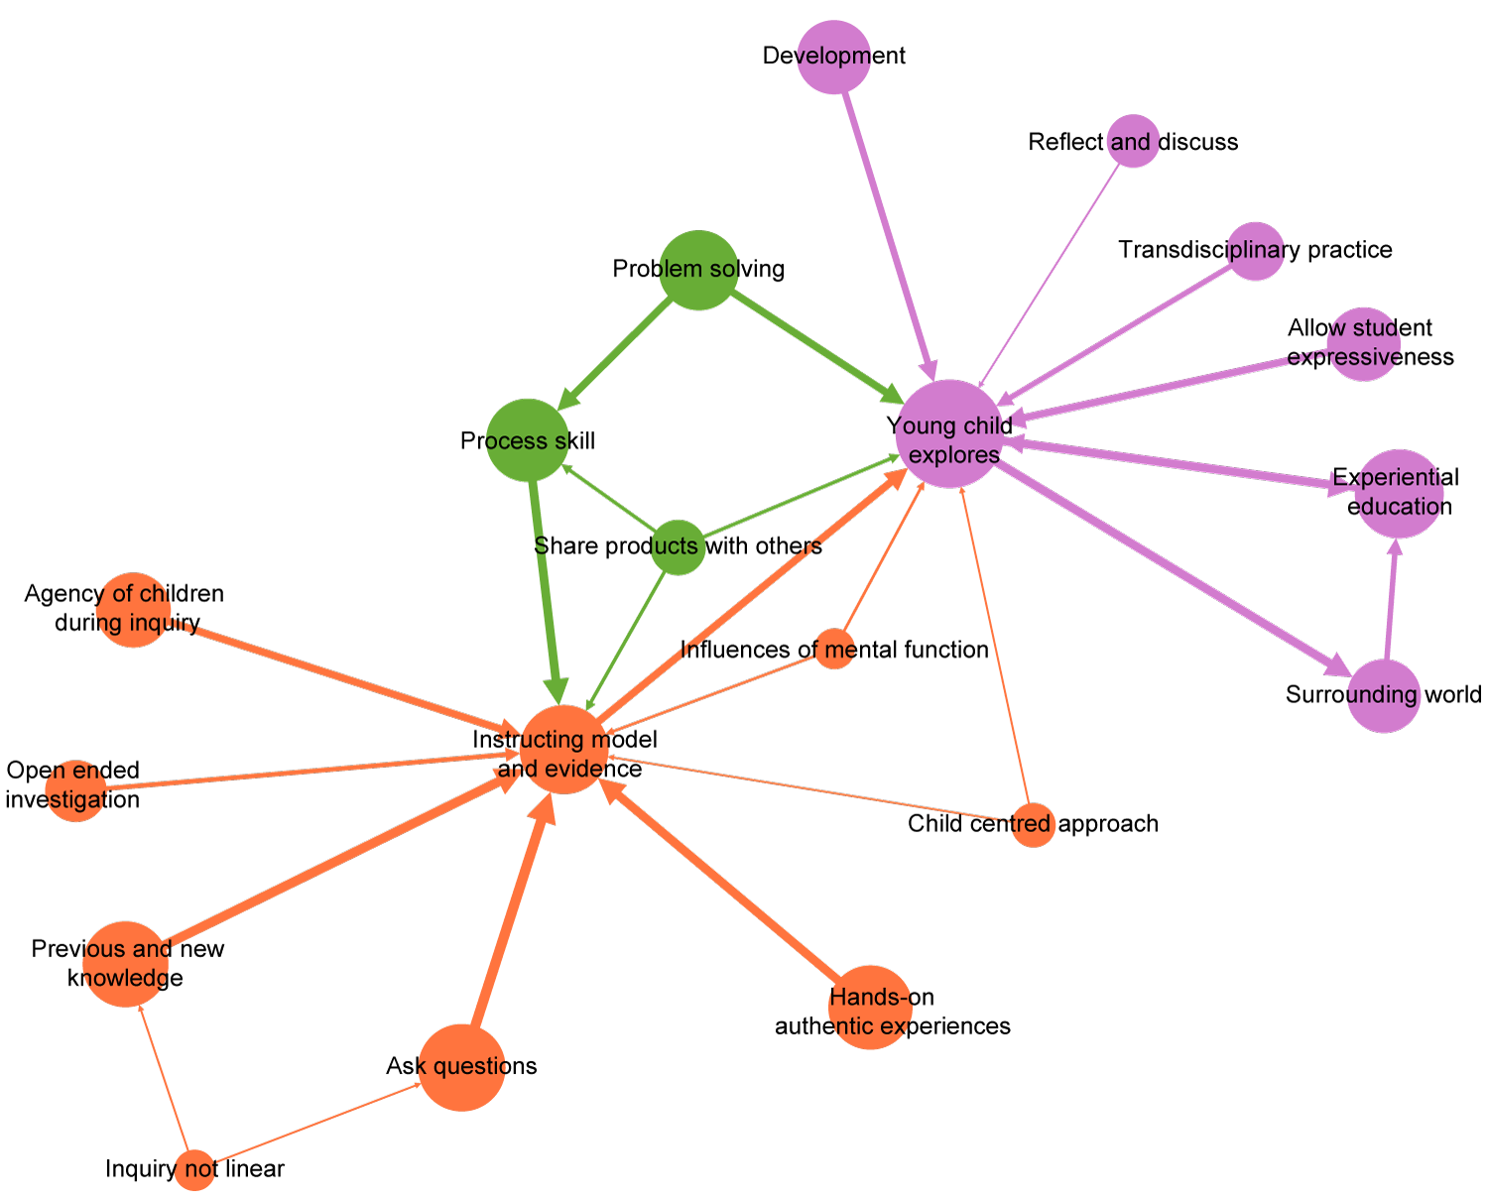

***Figure 3:*** *This study’s final thematic map of the theoretical excerpts. Overarching themes are colour coded. Size of circles represent the number of words within each (overarching) theme, and the size of arrows represent the number of connections between each (overarching) theme.*

Figure 3 shows our final thematic map for the theoretical excerpts. The map contains 19 themes. Using community detection, we were able to group themes into three clusters of overarching themes shown in colour in Figure 3. Overall interpretative description below is followed by a more detailed analysis of each overarching theme. Below, overarching themes are *italicized and underlined*, while themes and words are *italicized*.

The orange-coloured themes comprise the themes: *Instruction models and evidence, Child inquiry agency, Open-ended investigation, Previous and new knowledge, Inquiry not linear, Ask questions, Hands-on authentic experiences, Child-centred approach,* and *Influences of mental function*.  As we will argue below, this overarching theme seems to capture a group of theoretical descriptions of inquiry that aims at modelling science education practice through a phase-driven instructional model. Accordingly, we have named the first overarching theme: *Modelling scientific practice through teaching.*

The second overarching theme is composed of the three green themes: *Process skill, Problem solving,* and *Share products with others*. Together, these themes can be seen to encompass competencies that are crucial for learning, and we named the overarching theme *Developing science-related competencies*; our understanding of competencies include both knowing and doing, individually and with others (Ropohl et al., 2018, p. 10).

The purple themes constitute the third overarching theme: *Young child explores, Development, Reflective action, Pedagogical tools, Allow student expressiveness, Experiential education,* and *Surrounding world.* These themes emphasise a notion of inquiry, in which the experiences, development, and curiosity of the child takes centre stage as a starting point for inquiry, and in which the child’s playful exploration of the world is central. We named this overarching theme *Child exploration and experience of the world.*

We argue that the three overarching themes represent theoretical positions with regards to ECIBSE in the literature. In order to relate the map to the literature in detail, we now analyse each conceptualisation in turn linking network representations to the literature.

The Modelling scientific practice through teaching position

Almost all themes in the overarching theme point at the central *Instruction models and evidence*. One way to interpret this structure is to view themes that point to the central theme as elaborations of important aspects of that theme. With this interpretation*, Agency of children during inquiry, Open-ended investigations, Previous and new knowledge, asking questions,* and *Hands-on experiences* are important aspects to consider when applying inquiry instruction models. If we interpret the size of the circles (the number of words in the underlying theme networks) as an indicator of importance, these are roughly equally important. Thus, the three smaller orange themes are not prevalent in the theoretical positioning in the literature. Overall, the patterns in *Modelling scientific practice through teaching* draw attention to aspects of inquiry processes used by real scientists. García-Carmona et al. (2017, p. 990) provides an example of how references to scientific practice that is consistent with this conceptualisation:

*They* [the children] *use skills employed by scientists such as raising questions, collecting data, reasoning and reviewing evidence in the light of what is already known, drawing conclusions and discussing results.* (p. 990).

The instruction models presented in our literature-search varies from three to eight phases, with five being most prevalent (appearing in 13 papers). However, five-phase models are not identical. For example, in order to accommodate the early childhood age group, Desouza (2017) modifies the 5E model by Bybee et al. (2006).Three-phase models appear in seven papers as condensed versions of the 5E model. For example, the three-phased model E-E-R contextualizes inquiry and draws out children’s prior knowledge and invites predictions the three phases are engage, explore, and reflect (Gropen et al., 2017). The argument for modifying models is the limited cognitive and executive development in the age group (Gropen et al., 2017, Leuchter et al., 2014).

Instruction models with varied phases play a role to ensure implementation of processes like real scientists and act as a pedagogical structure to underpin planning of science activities.

*Agency of children during inquiry* represents how the child can be seen as an agent in an inquiry lesson. For example, Marget & Witherington (2011) compares what preschoolers do with what adults would do.  *Open-ended investigation* covers the view of inquiry through which adults allow students to investigate a prescribed problem, which has more than one correct solution, using their own methods as described in Leonard et al. (2009). Open-ended investigations are often seen as a landmark in instructional models like 5E (Bybee et al., 2006).

*Previous and new knowledge* is part of an instructional approach to inquiry. The theme contains the word *construct* and the link *construct->knowledge.* However, words and connections in the theme also suggest that there are constraints on the new knowledge which fit with modelling scientific practice. For example, formulating hypotheses, constructing explanations, and scientific forms of representation (such as language and symbols) are all part of this theme.

*Scientific practices* contain links such as *collect->data*, *ask->questions*, *make->observation*, and *interpret->observation*. We take this theme to represent the idea that children should engage in science-like practices as part of inquiry instruction.

*Hands-on and authentic experiences* may be seen as an elaboration of the nature of the activities, which children should learn from. Other ways of wording this sentiment include “real life” and “phenomena from every-day life.” The theme also highlights that time is a necessary component for such activities.

The Developing science-related competencies position

This position concerns the development of skills, literacy, and affect, which children should learn through inquiry. This development points to competencies which are broadly related to science rather than scientific practice.

The theme *Process skill* includes the words *process*, *skill*, *literacy*, *thinking skill*, *communication*, and *knowledge*. *Process* refers to ways by which to learn and experiment; in iterative cycles, in which skills are gradually learned. For example, Ilhan & Tosun (2016, p. 17) writes, “[s]cientific process skills are essential skills that every individual should have in order to become a science literate,” and “the most frequently repeated scientific process skills are observation, estimation, classification, using numbers, communication, measurement, data recording, problem solving, and reasoning skill.”

Problem solving as a theme appears as a many-faceted process that may involve constructing solutions to given tasks (Wu & Lin, 2016),  detecting and solving life-related problems in [the children’s] own ways” (Wu & Lin, 2016, p. 846),  and “as a means for supporting children to construct nuanced meanings of the world that surrounds them” (Philippou et al., 2015).  Solving problems is generally seen as part of inquiry and scientific literacy and can be connected to aesthetic, intellectual, and emotional states (Bruce & Casey, 2012), and may involve dialogical and collaborative elements (Bruce & Casey, 2012; Siry et al., 2012).

The ability and process of sharing with and learning from others is part of this theme: “The models students create are then shared, critiqued and refined within the classroom community with the goal of producing a shared collective model that can be used to understand and make predictions in new situations and contexts” (Enyedy et al., 2012, p. 348). In early childhood, it can be a challenge for teachers to facilitate sharing, “since early childhood students are [just] beginning to build early literacy skills” (Eckhoff, 2017, p. 220).

We believe that this position is an important bridging position between the two other positions, since it is important to focus on the child’s ability to even participate in the processes of inquiry as part of *Developing science-related competencies*. If children in a class do not have a concept of how one shares work or engage productively in a communicative process, then peer-discussions may not teach them to draw conclusions based on evidence.

The Child exploration and experience of the world position

In *Child exploration and experience of the world* two arrows point from the central *Young child explores*. One points to *Experiential education,* another to *Surrounding world*. This could signify that the *Young child explores* theme somehow modifies or informs these two other themes.

As a theme, *Young child explores* is characterised by thick connections from *young* to *child* and from *child* to *explore*. The word *child* iscentral in the sense that many words connect to it either directly or through other connections. As such, in this theme, *child* can be associated with encouragement, inciting, stimulating, empowering, assisting, and enabling. Likewise, the word *engage* is central and can be associated with engagement, open and focused exploration, inquisitiveness, progression, and motivation. In this theme, the curiosity, experience, language and decisions of the child seem to take prevalence. For instance, Enyedy et al. (2012) mentions participatory simulations, in which students make and evaluate rules that underlie a simulation and Siry et al. (2012) argues that children’s “science-related talk” often is “at the origin” of “standardized canonical discourse” (p. 314).

*Development* is characterised by two main connections: From *starting* to *point* and from concept to *develop(ment)*. In line with Dewey, the starting point of exploration in this position is seen as the child’s interest (e.g. Bruce & Casey, 2012) and exploration (e.g. Enyedy et al., 2012).  Conceptual development is seen as a long-term endeavour (Decristian et al., 2015; Gropen et al., 2017), which may involve many aspects, such as children developing and exploring their own explanations, models, and concepts. At the same time, children are seen as developing as we believe is captured by McNerney & Hall (2017, p. 207):

“*For scientific thinking to develop through childrens’ exploratory play and observations, children should, at some stage, be able to interpret and make sense of their experiences so that they can gain a better understanding of the world around them.*”

Children should develop their thinking by actively trying to develop their interpretations of experiences. Here, curiosity can drive action so that the engaged learner comes to own the inquiry process (Bruce & Casey, 2012; Samarapungavan et al., 2009; Senocak et al., 2013; Van hook & Huziak-Clark, 2008). The importance of curiosity is highlighted by Ilhan & Tosun (2016) who point out that science in ECE should be directed toward satisfying the curiosity of children, rather than providing information on scientific concepts.

*Allow student expressiveness* is built on the network connection *allow ->* *student* andrepresents the varied ways in which children as active learners are allowed hands-on experiences, participation in socio-dramatic role play, or even to initiate and lead the inquiry activity (Enyedy et al., 2012; Hollingsworth & Vandermaas-Peeler, 2017). In addition, *Allow student expressiveness* mirrors the challenges of ECEIBSE found in *Share with others*; finding alternative ways to encourage young children to express and visualise their own thinking can be an important element of ECIBSE (Eckhoff, 2017). Specific media include visual arts media, drawings, use of play doh, and digital photography (Eckhoff, 2017; Enyedy et al. 2012; Fridberg et al., 2018; Leuchther et al., 2014)

The strong connection from *Young child explores* to *Surrounding world* is unsurprising in that it resembles what children should explore; the strongest link in *Surrounding world* goes from *world* to *around*. The S*urrounding world* includes the material, natural, social, and individual world. Thus, we interpret the link from *Young child explores* to *Surrounding world* as a prescription of what should be explored.

The *Young child explores* theme also has a strong connection to the *Experiential education* theme in Figure THEORETICAL MAP.  The strongest connection in the theme is *early* -> *childhood*, and from childhood links go to *teacher* and *education*. Furthermore, links make up the chain: *experiential* -> *education* -> *context*. Both *teacher* and *context* are central words in this theme. Taken together with our reading of the theoretical excerpts, we see this theme as representative of the broader educational context for ECIBSE that emphasises the young child’s exploration, experience-making and reflection.

Summary of thematic network analysis of theoretical excerpts

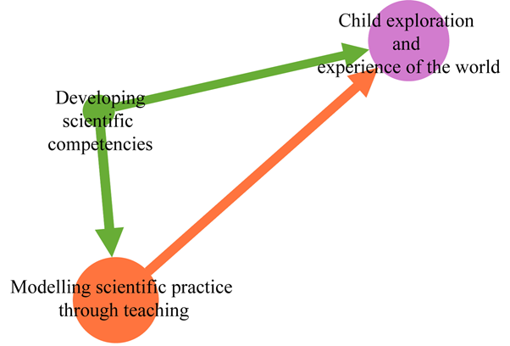

***Figure 4:*** *A map of the three theoretical positions described above. Each coloured circle represents one of the three positions we have identified; they are collections of the themes with corresponding colours in Figure 3*. *The arrows represent the collected connections from themes representing one position to themes representing another position.*

Figure 4 also shows a link from *Modelling scientific practice through teaching*  to *Child exploration and experience of the world*. This is mainly due to the direct connection from Instruction models and evidence to *Young child explores*. This connection from words and phrases in *Young child explores* modifying words and phrases in *Instruction models and evidence*; for example, that the child’s interest should be taken into account in instructional models. Another reason for this connection is that the word explore is both a phase in many instructional models and an action that children should take.

Discussion and reflection on findings

As described, we combine qualitative thematic analysis and quantitative networks analysis. We will in this section first discuss strength and weaknesses of this approach. Secondly, we will discuss the tensions identified in contemporary literature through analysis and relate the finding to the origins of inquiry.

The origins of inquiry as seen from a Deweyan perspective is an experiential education which aims at creating educative situations with active participants. Even at the origins of inquiry there seemed to be a tension between inquiry as scientific practice, where the aim is to make sense and evidence of data and child-centred experiential education, where the aim is to underpin meaningful learning with the curiosity of the child.  We believe that our findings illustrate that this tension is still present.

The four different positions we found in excerpts and the difference between their prevalence and connections, merit a discussion of a theory-practice gap and a science-pedagogy gap. The theory-practice gap appears as a lack of the *Developing science-related competency* as mediating between *Modelling scientific practice through teaching* and *Child exploration and experience of the world* positions when ECIBSE is implemented. The science-pedagogy gap appears as the non-reciprocal connections between *Modelling scientific practice through teaching*, representing science, and *Child exploration and experience of the world* position representing the field of pedagogy. In this interpretation, *Developing science-related competency* may represent the field of science education. This could lead to a discussion of whether practical implementations in ECIBSE tend to place too much weight on either achieving science knowledge or the child’s interest and exploration and not on bridging the two through a contemporary view of competency development.

In addition, the positions warrant a discussion of what should be learned in ECE and what should be learned later in school. For example, with respect to the cognitive and executive level of development (Hollingworth & Vandermaas-Peeler, 2017), letting the children experience how to cooperate before asking them to discuss may be beneficial. For the same reasons, letting children learn to observe, classify, and ask their own questions might be a part of a science-related competency to be developed before learning to draw conclusions based on evidence.

However, we argue that this analysis contributes to a deeper understanding of ECIBSE and raises questions worth reflecting on with regards to the role played by scientific practice, when implemented in ECE settings.  The positions we found may expand discussions about whether children should learn scientific practice like real scientists or explore the world as creative beings, which in many cases take on a dichotomous nature. We can now add to those discussions by pointing out that development of science-related competencies might be at the nexus of developing children’s capacity to initiate their own explorations and gain agency in learning science.

The different positions may give rise to very different pedagogical emphasis and thus very different teaching and teacher competencies. The *Modelling scientific practice through teaching* position would emphasise teachers with strong scientific grounding with a danger of diminishing the drive from genuine curiosity and thereby the child’s initiative. The *Child exploration and experience of the world* position would in contrast require teachers to value the child’s curiosity and applaud its initiative, with the danger of neglecting the child’s development of scientific knowledge and practice.og så noget med kontinuitet Rejecting the apparent dichotomy, we believe important questions remain: For whom, what and how is science supposed to create value? In what way is *modelling scientific practice through teaching* valuable from the child's perspective? How can a *child's exploration and experience of the world* open for qualified science experiences in early childhood? Which science-related competencies should be developed during early childhood? In answering these questions, we advocate that future research follows Dewey’s mediating path by carefully foster situations based on the philosophy of experience (Dewey 1938/2015).

References

AUTHOR (2019)

AUTHOR (in press)

Alake-Tuenter, E., Biemans, H. J., Tobi, H., Wals, A. E., Oosterheert, I., & Mulder, M. (2012). Inquiry-based science education competencies of primary school teachers: A literature study and critical review of the American National Science Education Standards. *International Journal of Science Education, 34*(17), 2609-2640.

Attride-Stirling, J. (2001). Thematic networks: an analytic tool for qualitative research. *Qualitative Research.* Volume: 1, issue: 3, pp: 385-405.

Bastian, M., Heymann, S., & Jacomy, M. (2009). Gephi: an open source software for exploring and manipulating networks. In *Third international AAAI conference on weblogs and social media*.

Biesta, G. J., & William, N. C. B. E. (2003). Pragmatism and Educational Research. *Philosophy, Theory, and Educational Research Series*. USA: Rowman & Littlefield publishers Inc.

Braun, V., & Clarke, V. (2006). Using thematic analysis in psychology. *Qualitative research in*

*psychology, 3*(2), 77‑101. doi:10.1191/1478088706qp063oa.

Bruce, B. C., & Casey, L. (2012). The Practice of Inquiry: A Pedagogical "Sweet Spot" for Digital Literacy? *Computers in the Schools, 29*(1-2), 191-206.

Bybee, R. W., Taylor, J. A., Gardner, A., Van Scotter, P., Powell, J. C., Westbrook, A., & Landes, N. (2006). The BSCS 5E instructional model: Origins and effectiveness. *Colorado Springs*, Co: BSCS, 5, 88-98.

Clauset, A., Newman, M. E., & Moore, C. (2004). Finding community structure in very large networks. *Physical review*, 70(6), 066111.

Csardi, G., & Nepusz, T. (2006). The igraph software package for complex network research. *InterJournal, complex systems*, *1695*(5), 1-9.

Decristan, J., Hondrich, A. L., Büttner, G., Hertel, S., Klieme, E., Kunter, M., ... & Naumann, A. (2015). Impact of additional guidance in science education on primary students’ conceptual understanding. *The Journal of Educational Research*, *108*(5), 358-370.

Desouza, J. M. S. (2017). Conceptual Play and Science Inquiry: Using the 5E Instructional Model. *Pedagogies: An International Journal, 12*(4), 340-353.

Dewey, J. (1938/2015). Experience and education. *New York: Simon & Schuster*

Dewey, J. (2005). Art as experience. *New York Penguin Putnam Inc.*

Dewey, J. (2011). Democracy and Education. *In (Simon & Brown Edition ed.): Milton Keynes: Lightning Source UK Ltd.*

Dewey, J. (2013). Logic, the theory of inquiry, 1938. *Southern University Press.*

Eckhoff, A. (2017). Partners in inquiry: A collaborative life science investigation with preservice teachers and kindergarten students. *Early Childhood Education Journal, 45*(2), 219-227.

Enyedy, N., Danish, J. A., Delacruz, G., & Kumar, M. (2012). Learning Physics through Play in an Augmented Reality Environment. *International Journal of Computer-Supported Collaborative Learning, 7*(3), 347-378.

Eshach, H., & Fried, M. N. (2005). Should science be taught in early childhood? *Journal of science education and technology*, *14*(3), 315-336.

Ingo Feinerer and Kurt Hornik (2019). tm: Text Mining Package. *R package version 0.7-7.* Retrieved from: <https://CRAN.R-project.org/package=tm>

Foti, N. J., Hughes, J. M., & Rockmore, D. N. (2011). Nonparametric sparsification of complex multiscale networks. *PloS one, 6*(2), e16431.

Fridberg, M., Thulin, S., & Redfors, A. (2018). Preschool Children's Collaborative Science Learning Scaffolded by Tablets. *Research in Science Education, 48*(5), 1007-1026.

Furtak, E. M., Seidel, T., Iverson, H., & Briggs, D. C. (2012). Experimental and quasi-experimental studies of inquiry-based science teaching: A meta-analysis. *Review of Educational Research, 82*(3), 300-329.

García-Carmona, A., Criado, A. M., & Cruz-Guzmán, M. (2017). Primary Pre-Service Teachers' Skills in Planning a Guided Scientific Inquiry. *Research in Science Education, 47*(5), 989-1010.

Gropen, J., Kook, J. F., Hoisington, C., & Clark-Chiarelli, N. (2017). Foundations of Science Literacy: Efficacy of a Preschool Professional Development Program in Science on Classroom Instruction, Teachers' Pedagogical Content Knowledge, and Children's Observations and Predictions. *Early Education and Development, 28*(5), 607-631.

Martin-Hansen, Lisa. "Defining inquiry." *The science teacher* 69.2 (2002): 34

Harlen, W., & Allende, J. (2006). IAP Report of the Working Group on the International Collaboration in the Evaluation of IBSE programs. *Fundacion para Biomedicis Avanzados do la Facultad de Medicina, University of Santiago, Chile*.

Hollingsworth, H. L., & Vandermaas-Peeler, M. (2017). "Almost Everything We Do Includes Inquiry": Fostering Inquiry-Based Teaching and Learning with Preschool Teachers. *Early Child Development and Care, 187*(1), 152-167.

Ilhan, N., & Tosun, C. (2016). Kindergarten Students' Levels of Understanding Some Science Concepts and Scientific Inquiry Processes According to Demographic Variables (The Sampling of Kilis Province in Turkey). *Cogent Education, 3*(1).

Johnson, B., & Christensen, L. (2014). Educational research: Quantitative, qualitative, and mixed approaches(5th edition). *Los Angeles: Sage.*

Kallery, M., Psillos, D., & Tselfes, V. (2009). Typical Didactical Activities in the Greek Early-Years Science Classroom: Do They Promote Science Learning? *International Journal of Science Education, 31*(9), 1187-1204.

Lanphear, J., & Vandermaas-Peeler, M. (2017). Inquiry and Intersubjectivity in a Reggio Emilia-Inspired Preschool. *Journal of Research in Childhood Education, 31*(4), 597-614.

Leonard, J., Boakes, N., & Moore, C. M. (2009). Conducting Science Inquiry in Primary Classrooms: Case Studies of Two Preservice Teachers' Inquiry-Based Practices. *Journal of Elementary Science Education, 21*(1), 27-50.

Leuchter, M., Saalbach, H., & Hardy, I. (2014). Designing Science Learning in the First Years of Schooling. An Intervention Study with Sequenced Learning Material on the Topic of "Floating and Sinking". *International Journal of Science Education, 36*(10), 1751-1771.

Martin-Hansen, L. (2012). Defining inquiry – Exploring the many types of inquiry in the science classroom. *The Science Teacher.* Washington. Vol. 69, Iss. 2, pp. 34-37.

MacDonald, K., & Breunig, M. (2018). Back to the "Garten": Ontario Kindergarteners Learn and Grow through Schoolyard Pedagogy. *Journal of Outdoor and Environmental Education, 21*(2), 133-151.

McNerney, K., & Hall, N. (2017). Developing a Framework of Scientific Enquiry in Early Childhood: An Action Research Project to Support Staff Development and Improve Science Teaching. *Early Child Development and Care, 187*(2), 206-220.

Merritt, E. G., Chiu, J., Peters-Burton, E., & Bell, R. (2018). Teachers' Integration of Scientific and Engineering Practices in Primary Classrooms. *Research in Science Education, 48*(6), 1321-1337.

Metz, K. E. (2008). Narrowing the Gulf between the Practices of Science and the Elementary School Science Classroom. *Elementary School Journal, 109*(2), 138-161.

Minner, D. D., Levy, A. J., & Century, J. (2010). Inquiry‐based science instruction—what is it and does it matter? Results from a research synthesis years 1984 to 2002. *Journal of Research in Science Teaching, 47*(4), 474-496.

National Research Council. (2012). *A framework for K-12 science education: Practices, crosscutting concepts, and core ideas*. Washington, DC: The National Academies Press.

Pedaste, M., Mäeots, M., Siiman, L. A., De Jong, T., Van Riesen, S. A., Kamp, E. T., Tsourlidaki, E. (2015). Phases of inquiry-based learning: Definitions and the inquiry cycle. *Educational Research Review, 14*, 47-61.

Peterson, S. M., & French, L. (2008). Supporting Young Children's Explanations through Inquiry Science in Preschool. *Early Childhood Research Quarterly, 23*(3), 395-408.

Petticrew, M., & Roberts, H. (2008). Systematic reviews in the social sciences: A practical guide. *John Wiley & Sons.*

Philippou, S., Papademetri-Kachrimani, C., & Louca, L. (2015). "The Exchange of Ideas Was Mutual, I Have to Say": Negotiating Researcher and Teacher "Roles" in an Early Years Educators' Professional Development Programme on Inquiry-Based Mathematics and Science Learning. *Professional Development in Education, 41*(2), 382-400.

R Core Team (2019). *R: A language and environment for statistical computing.* Vienna, Austria. Retrieved from: https://www.R-project.org/.

Ropohl, M., Nielsen, JA., Olley, C., Rönnebeck, S. & Stables, K. (2018). The concept of competence and its relevance for science, technology, and mathematics education. In J. Dolin & R. Evans (red), Transforming Assessment: Through an Interplay Between Practice, Research and Policy. *Springer, Contributions from Science Education Research, Vol. 4, pp. 3-2*

RStudio Team (2020). *RStudio: Integrated Development for R.* RStudio, PBC, Boston, MA. Retrieved from*:* http://www.rstudio.com/.

Rönnebeck, S. B., Sascha, Ropohl, M. (2016). Searching for a common ground–A literature review of empirical research on scientific inquiry activities. *Studies in Science Education, 52*(2), pp. 161-197.

Samarapungavan, A., Mantzicopoulos, P., Patrick, H., & French, B. (2009). The development and validation of the Science Learning Assessment (SLA): A measure of kindergarten science learning. *Journal of Advanced Academics, 20*(3), 502-535.

Samarapungavan, A., Patrick, H & Mantzicopoulos, P. (2011). What Kindergarten Students Learn in Inquiry-Based Science Classrooms. *Cognition & Instruction,* 29(4), 416-470

Senocak, E., Samarapungavan, A., Aksoy, P., & Tosun, C. (2013). A Study on Development of an Instrument to Determine Turkish Kindergarten Students' Understandings of Scientific Concepts and Scientific Inquiry Processes. *Educational Sciences: Theory and Practice, 13*(4), 2217-2228.

Siry, C., Ziegler, G., & Max, C. (2012). "Doing Science" through Discourse-in-Interaction: Young Children's Science Investigations at the Early Childhood Level. *Science Education, 96*(2), 311-336.

Van Hook, S. J., & Huziak-Clark, T. L. (2008). Lift, Squeeze, Stretch, and Twist: Research-Based Inquiry Physics Experiences (RIPE) of Energy for Kindergartners. *Journal of Elementary Science Education, 20*(3), 1-16.

Watts, M., Salehjee, S., & Essex, J. (2017). But is it science? *Early Child Development and Care, 187*(2), 274-283.

Wu, S.-C., & Lin, F.-L. (2016). Inquiry-Based Mathematics Curriculum Design for Young Children-Teaching Experiment and Reflection. *EURASIA Journal of Mathematics, Science & Technology Education, 12*(4), 843-860.